David Willis

Lingma Acheson

CIT 304

1.23.18

Course Project 1

Query 1 – Selects all columns from ADDRESS table where the last name of the person is “Bailey”

SELECT * FROM ADDRESS

WHERE LASTNAME='BAILEY';

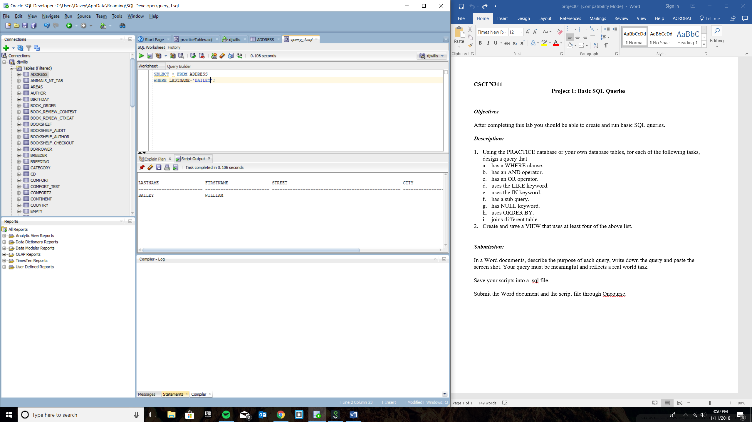

Query 2 – Select all columns from BOOKSHELF table where the publisher is “Scholastic” and the category name of the particular published book is “children fiction”

SELECT * FROM BOOKSHELF

WHERE PUBLISHER='SCHOLASTIC'

AND CATEGORYNAME='CHILDRENFIC';

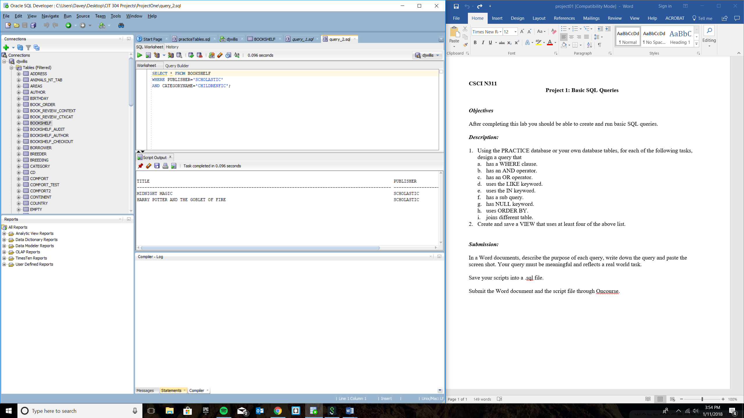

Query 3 – Select all columns from BOOKSHELF table where the publishers are “Scholastic” and “Harper Collins”

SELECT * FROM BOOKSHELF

WHERE PUBLISHER='SCHOLASTIC'

OR PUBLISHER='HARPERCOLLINS';

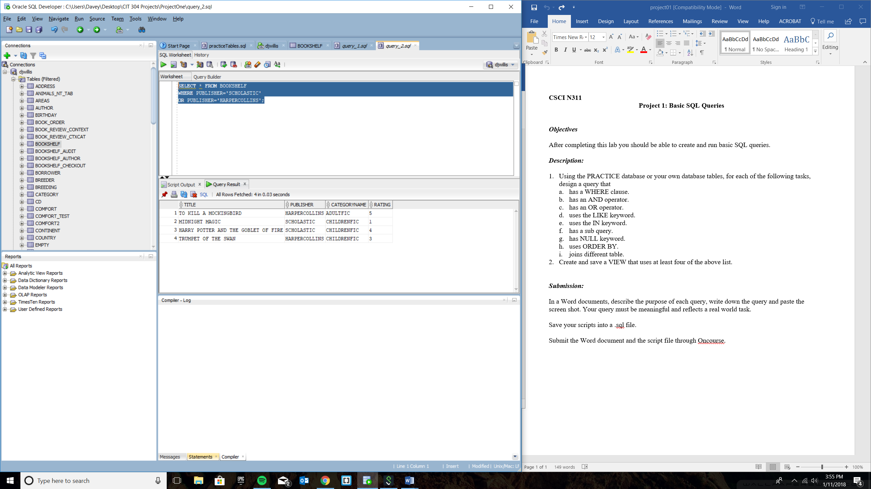

**Query 4 – Select all columns from ADDRESS table where the first name begins with the letter “w”**

**SELECT * FROM ADDRESS**

**WHERE FIRSTNAME LIKE 'W%';**

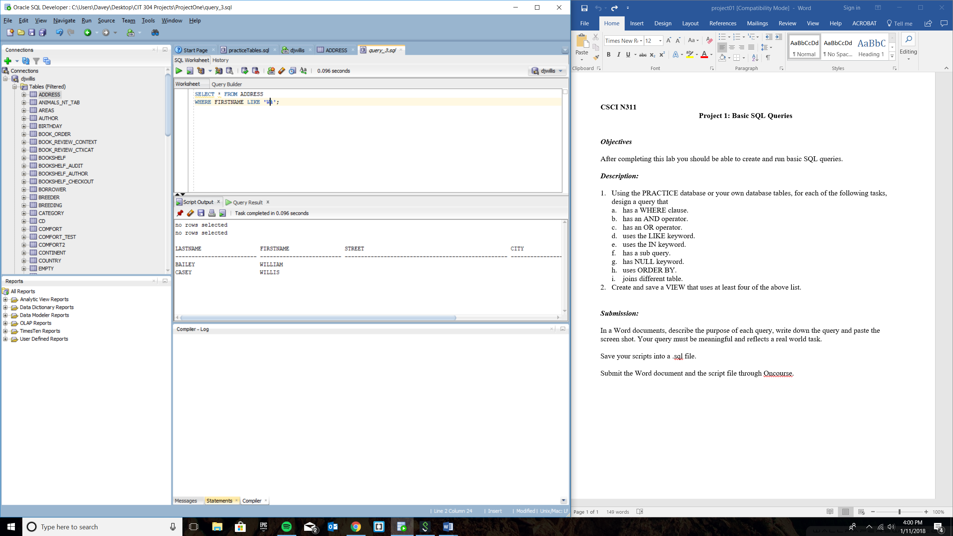

Query 5 – Select all columns from ADDRESS table where last name is either “Bailey”, “Casey”, or “Zack”

SELECT * FROM ADDRESS

WHERE LASTNAME IN ('BAILEY', 'CASEY', 'ZACK');

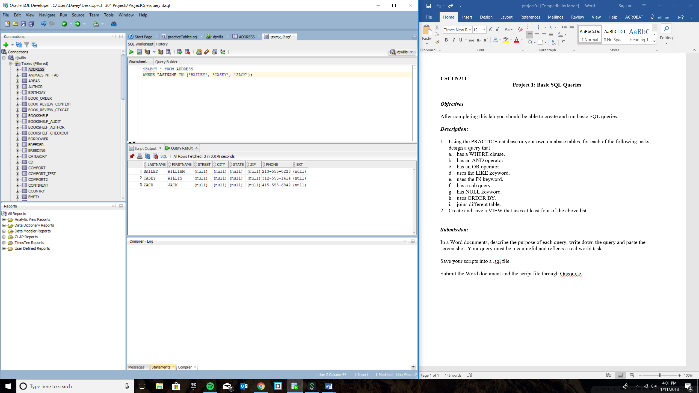

Query 6 – Select the specific columns TITLE, PUBLISHER, and CATEGORYNAME from BOOKSHELF table where the publisher is not “Harper Collins” nor “Viking”

SELECT TITLE, PUBLISHER, CATEGORYNAME

FROM BOOKSHELF

WHERE PUBLISHER NOT IN ('HARPERCOLLINS', 'VIKING');

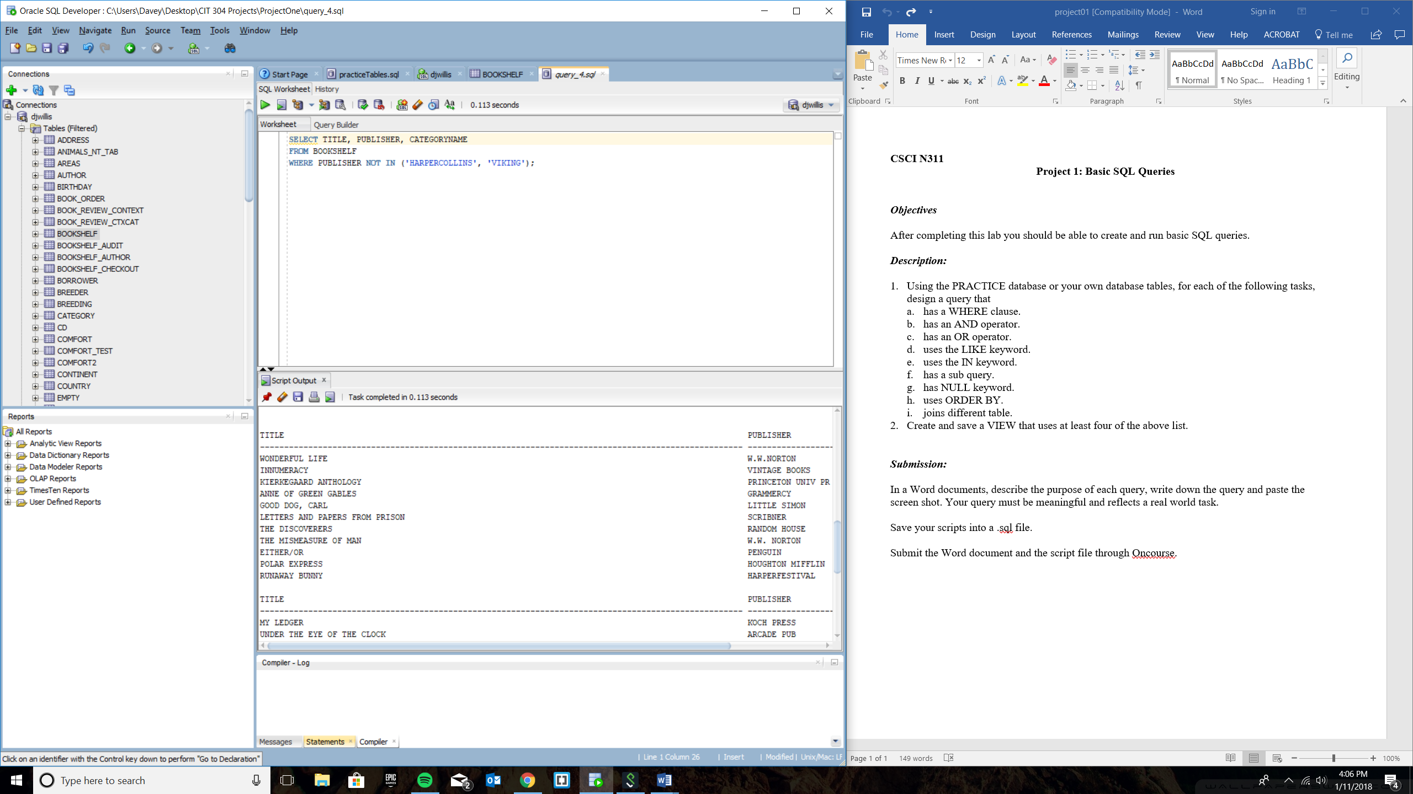

Query 7 – Select all columns from ADDRESS table where zip code has a legitimate value and is not left empty

SELECT *

FROM ADDRESS

WHERE ZIP IS NOT NULL;

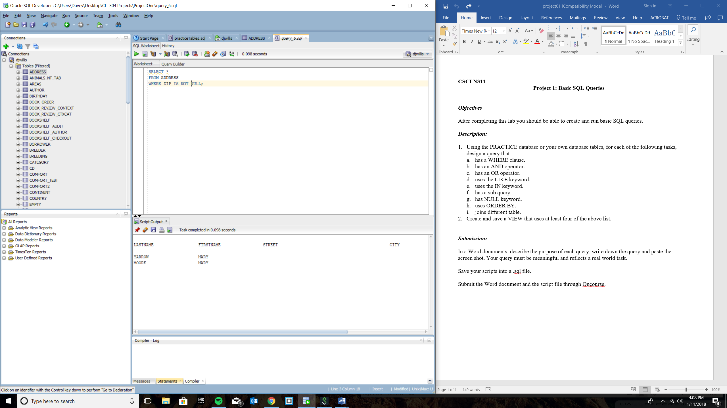

Query 8 – Select all columns from ADDRESS table and order the rows by last name in descending order (Z – A)

SELECT * FROM ADDRESS

ORDER BY LASTNAME DESC;

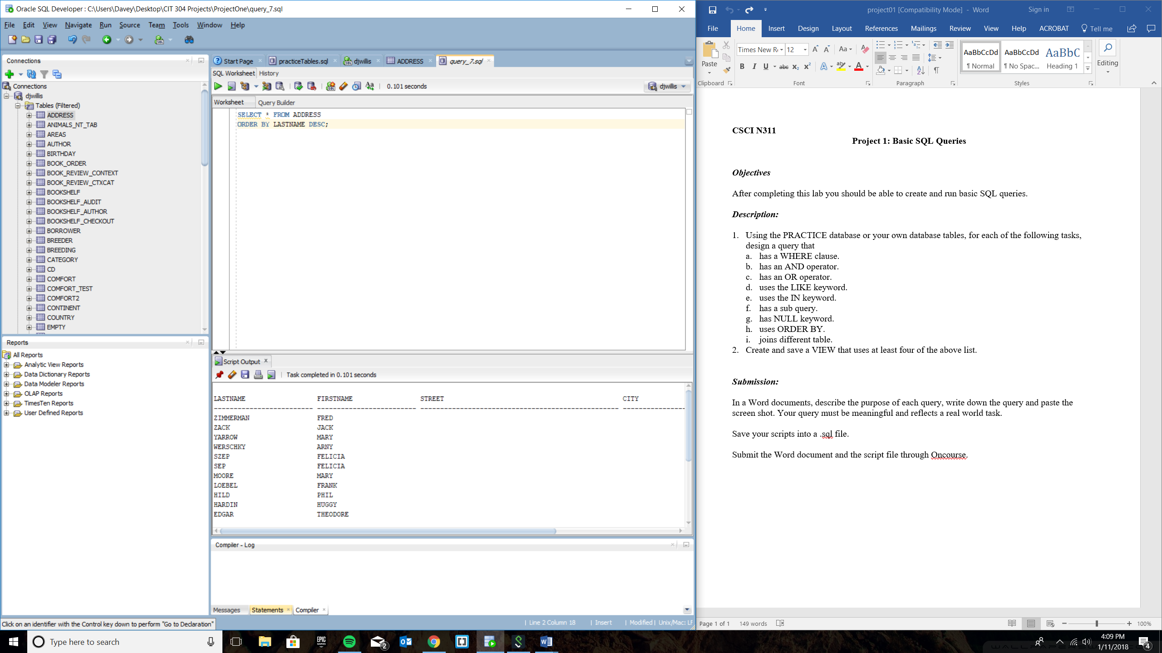

Query 9 – Select all columns from STOCK_ACCOUNT and STOCK_TRX tables and the join the two tables’ information only on the rows that contain the quantity of ‘100’

SELECT *

FROM STOCK_ACCOUNT JOIN STOCK_TRX

ON STOCK_ACCOUNT.ACCOUNT = STOCK_TRX.ACCOUNT

WHERE QUANTITY='100';

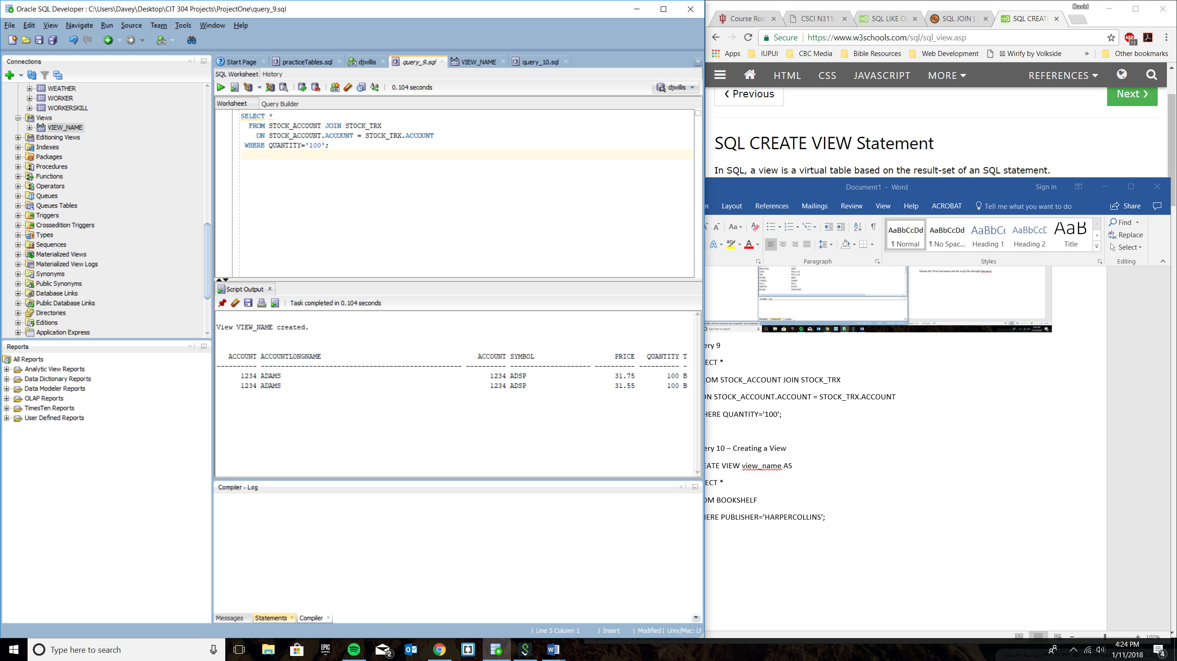

View 1 – Creating a View using at least four of the above list

CREATE VIEW view_name AS

SELECT *

FROM BOOKSHELF

WHERE PUBLISHER='HARPERCOLLINS';

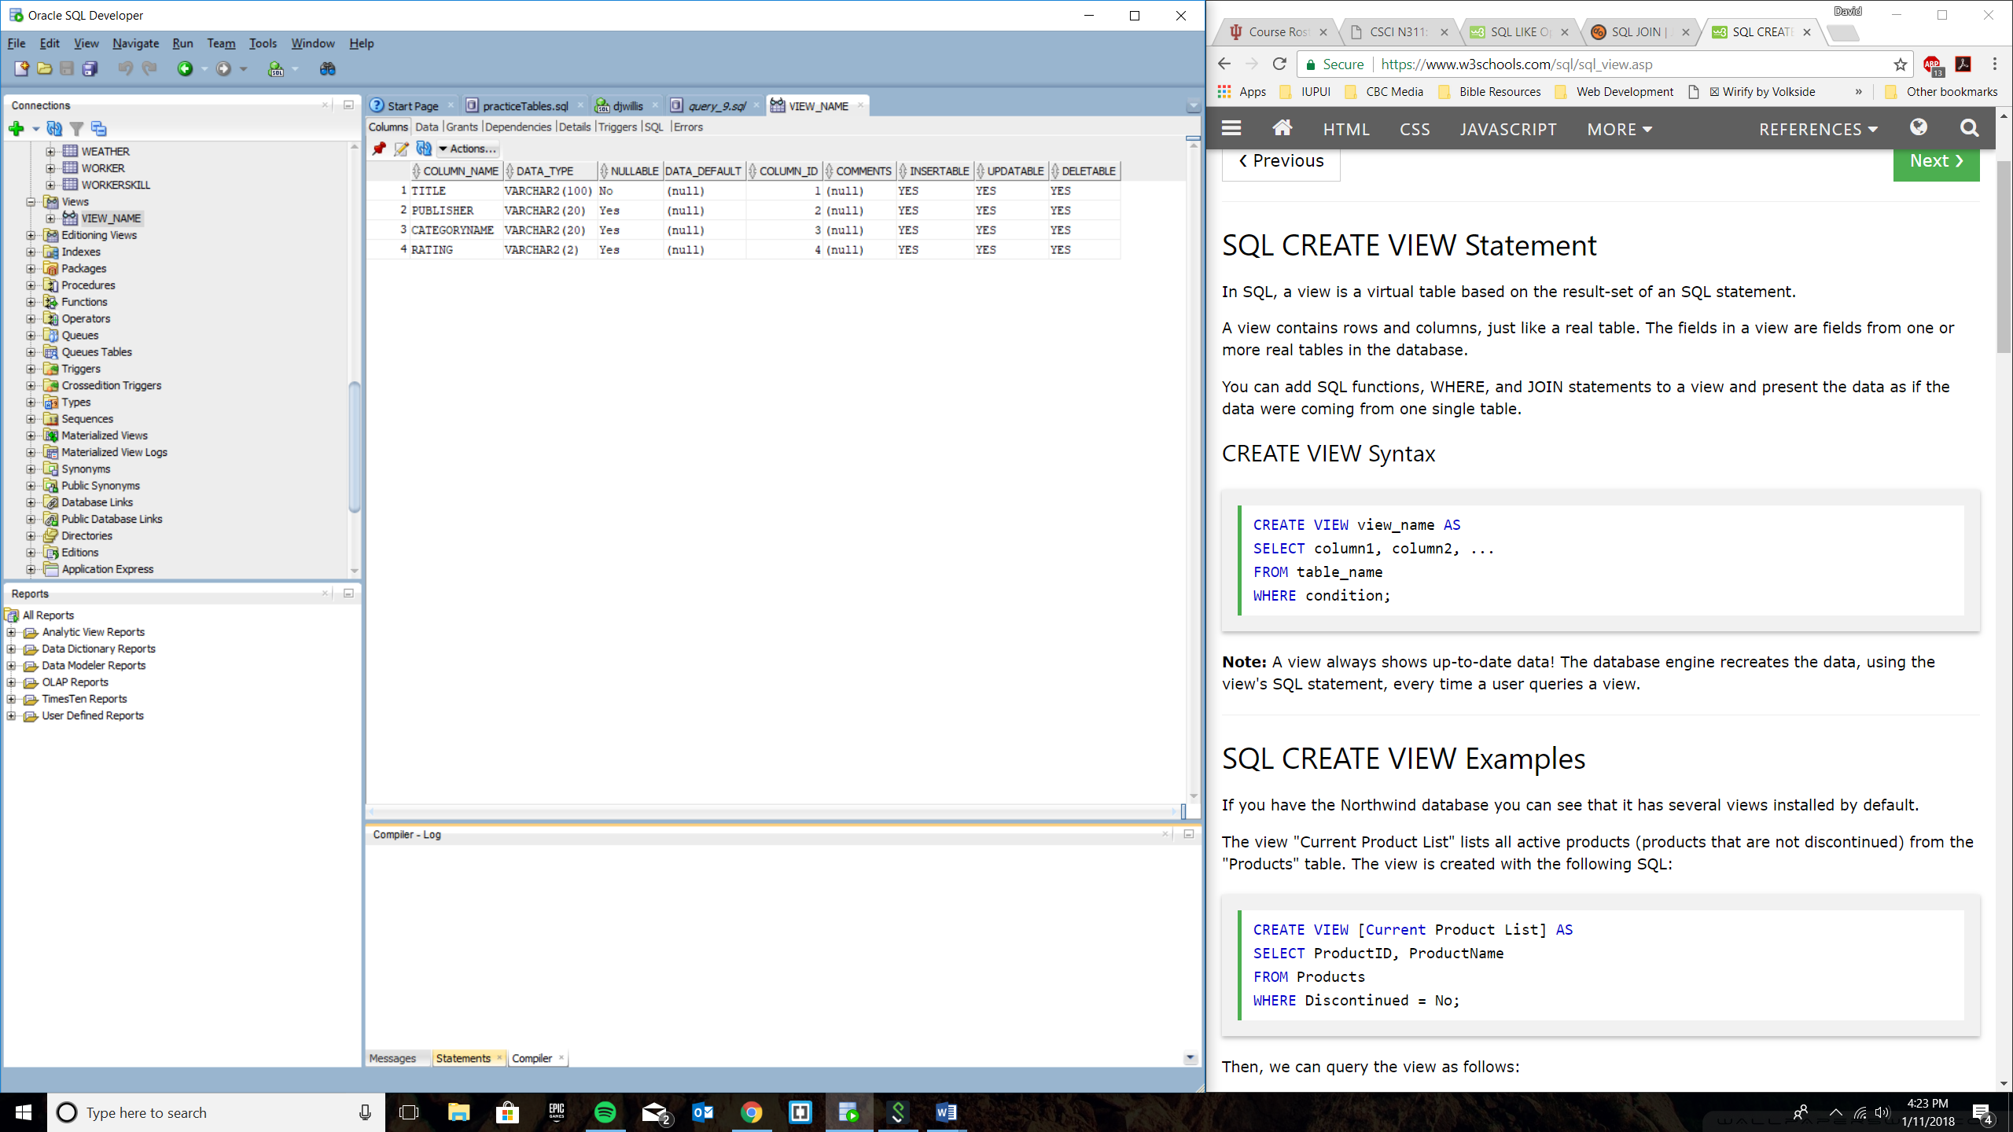

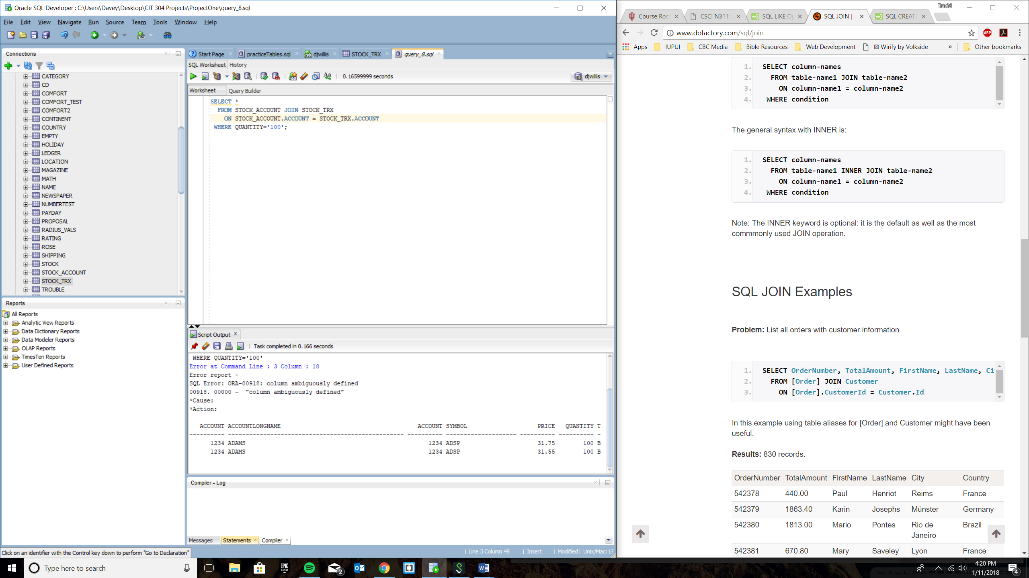

View 2

CREATE VIEW VIEW_WHERE AS

SELECT * FROM ADDRESS

WHERE LASTNAME='BAILEY';

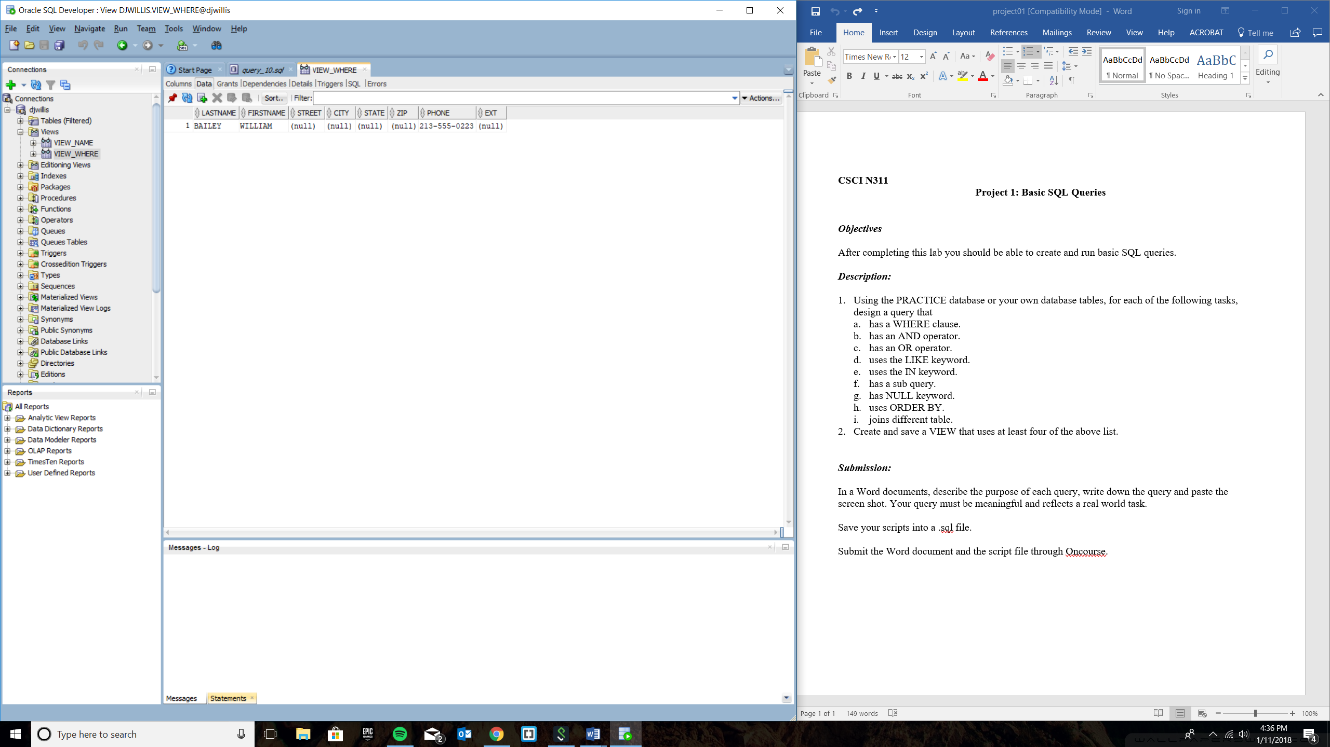

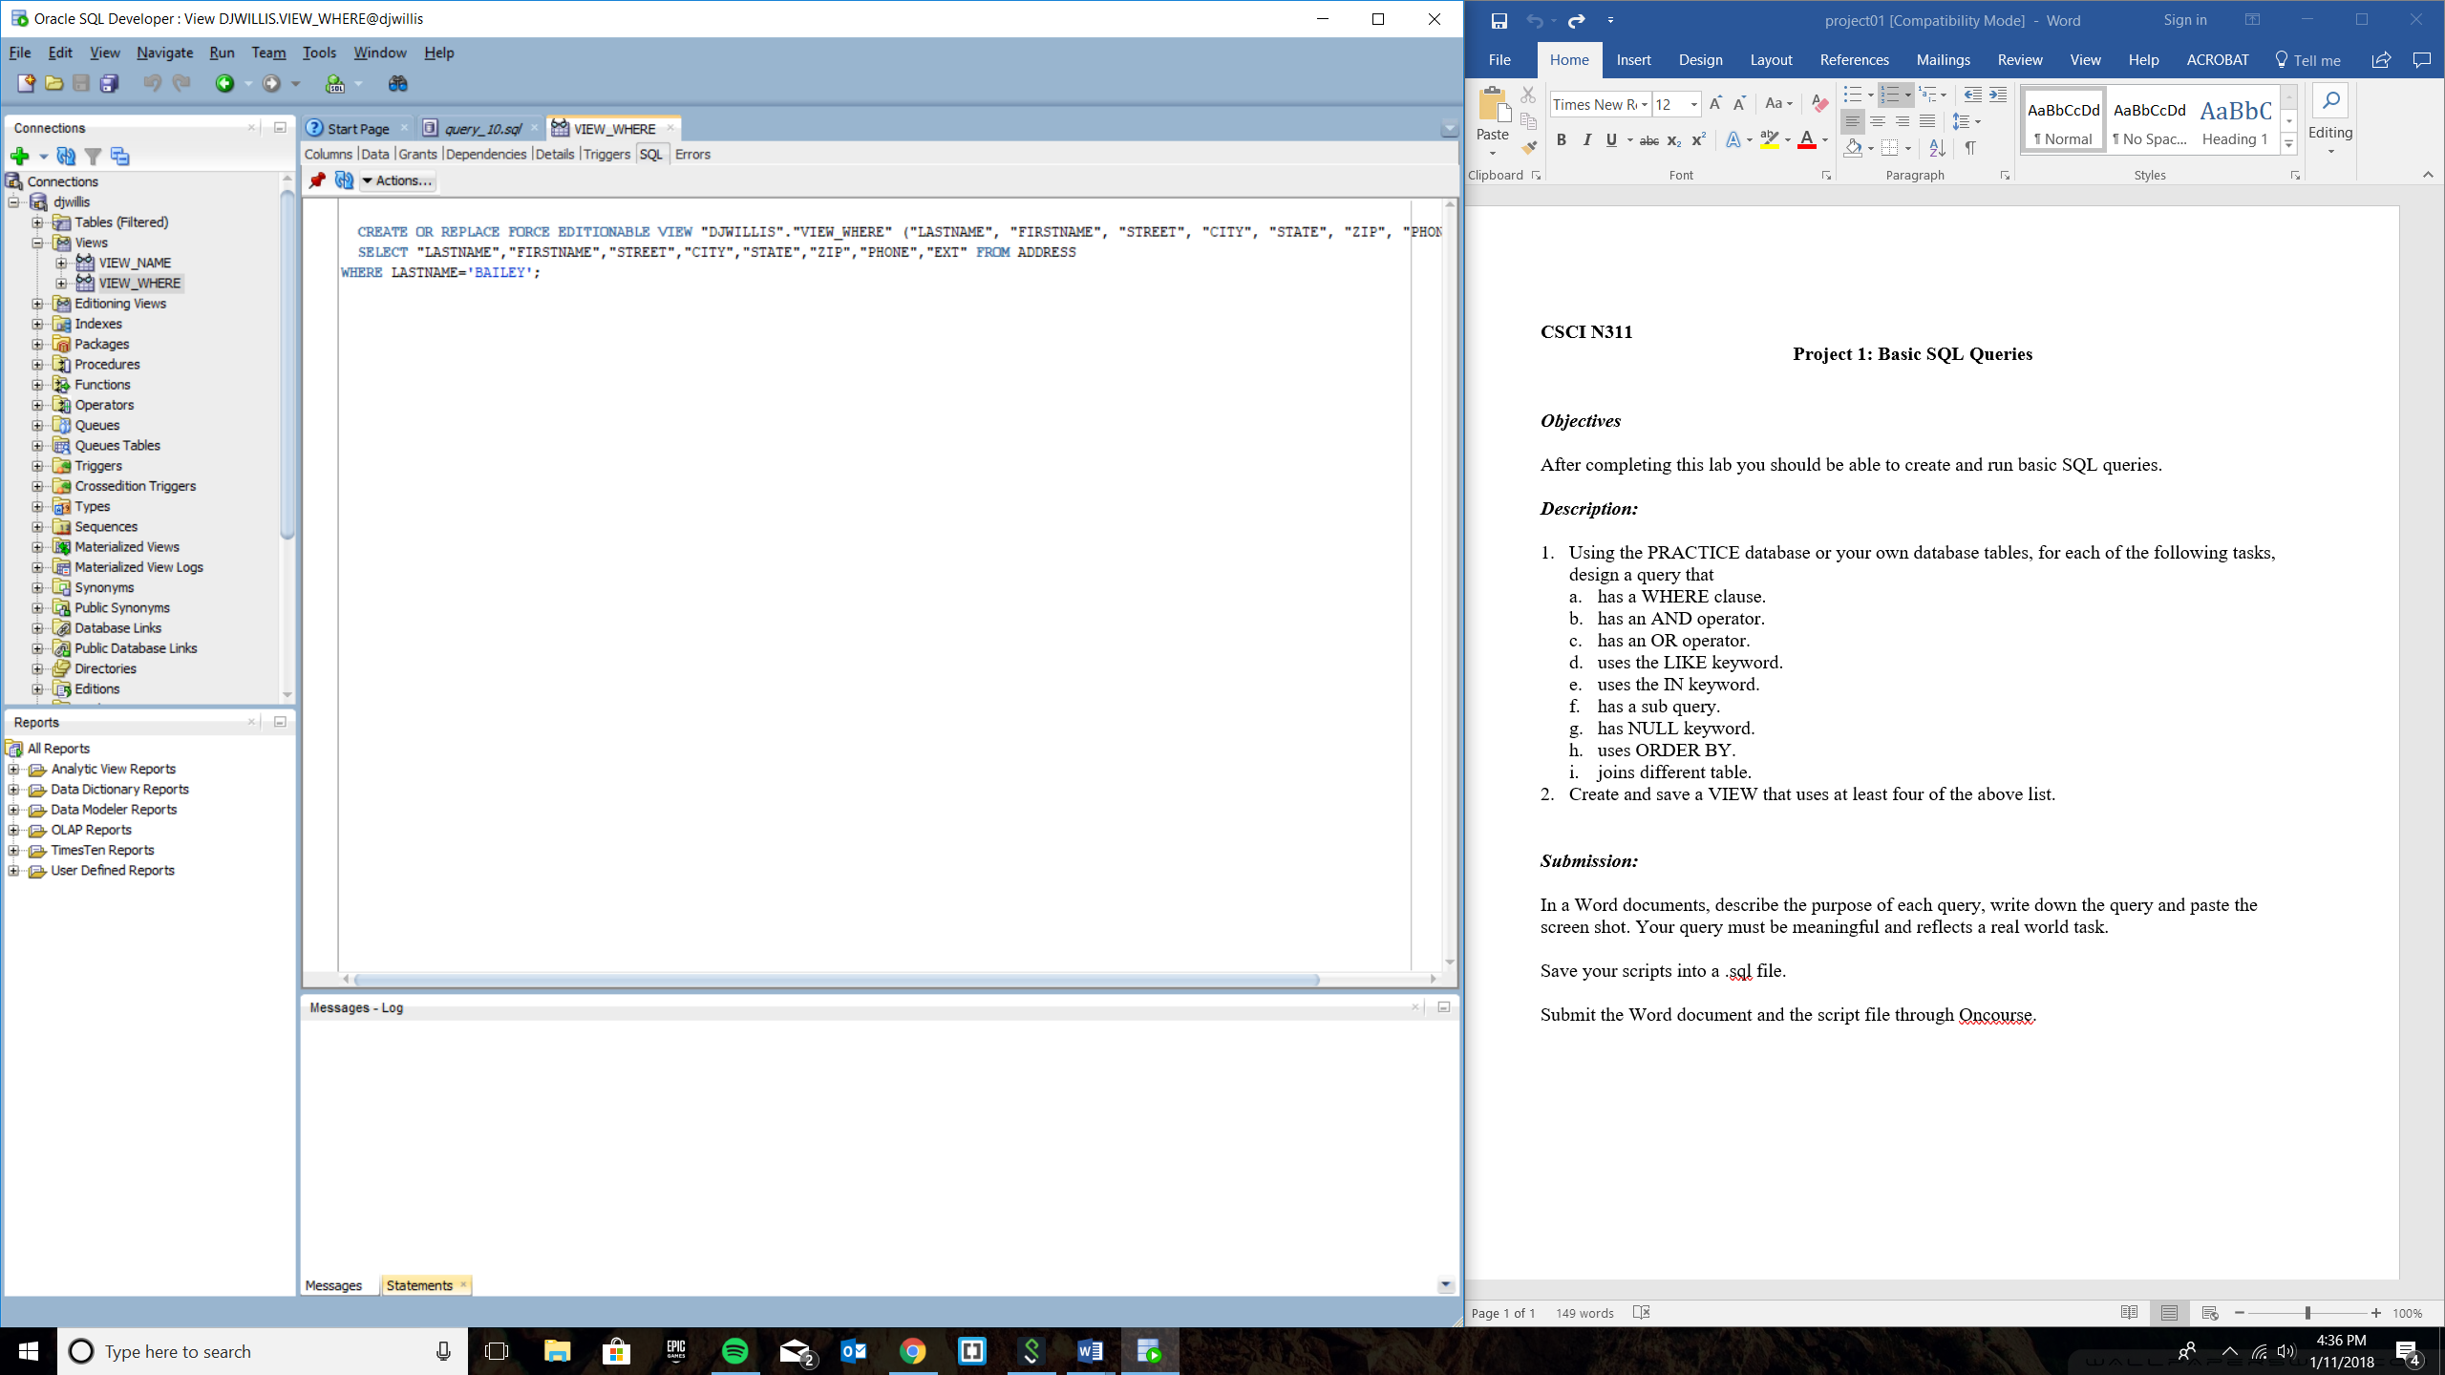

View 3

CREATE VIEW VIEW_AND AS

SELECT * FROM BOOKSHELF

WHERE PUBLISHER='SCHOLASTIC'

AND CATEGORYNAME='CHILDRENFIC';

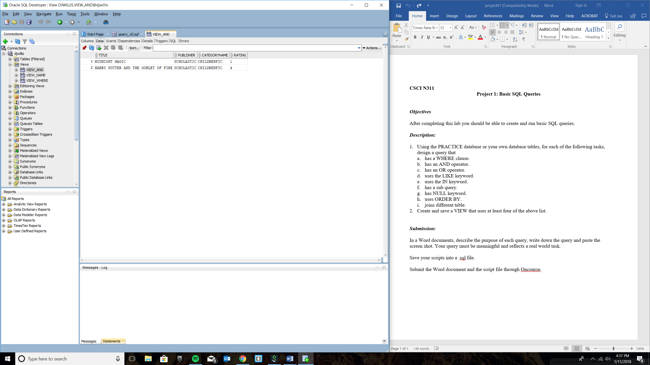

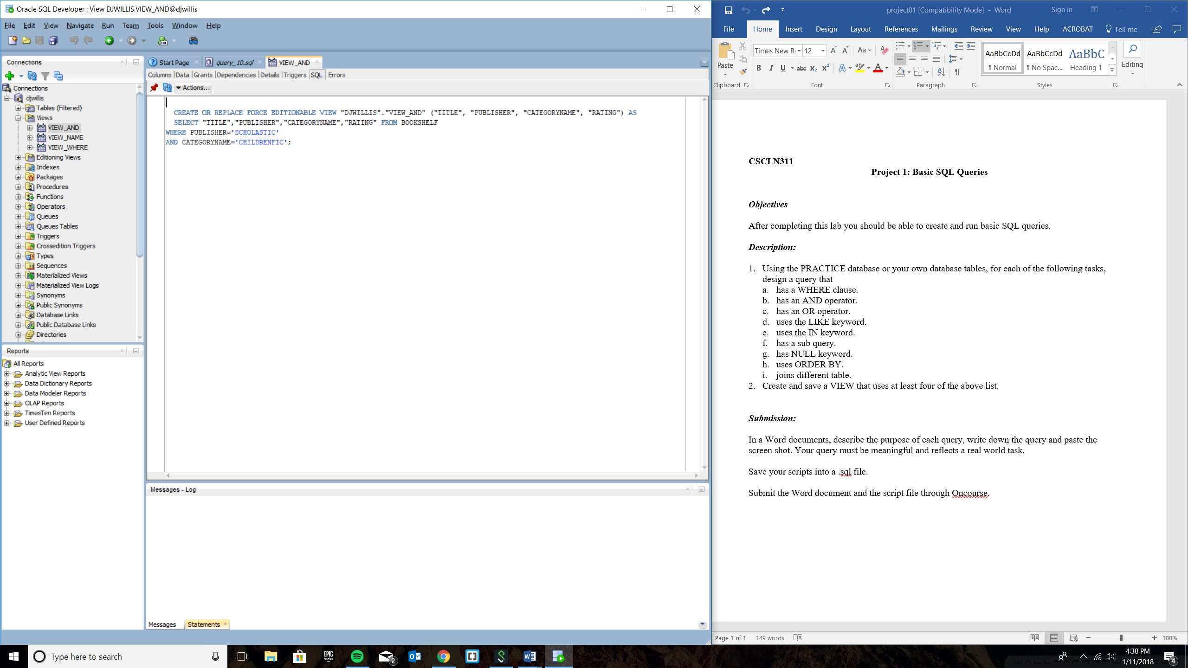

View 4

CREATE VIEW VIEW_AND AS

SELECT * FROM ADDRESS

WHERE LASTNAME IN ('BAILEY', 'CASEY', 'ZACK');

